JAI SHREE ALLAH HU DA KHALSA HOLI SPIRIT DI FATEH

1. Expand 𝑓(𝑥)=𝑥𝑠𝑖𝑛𝑥,0<𝑥< $π$

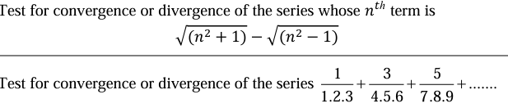

1. Find the Half range cosine series for the function 𝑓(𝑥)=(𝑥−1)2 in 𝑡ℎ𝑒 𝑖𝑛𝑡𝑒𝑟𝑣𝑎𝑙 0<𝑥<1

Or

Obtain the Half range sine series for the function f(t) ={ 𝑡 0<t<t2

4-t 2<t<4

1. 